1. I believe the population, sex, and flock columns will be useful for beta and alpha diversity. Population will help distinguish between migratory vs.resident. Sex can help if diversity differs between sex. Flock will help for diversity analysis as it groups sex and population together.
2. Based on the plot, I would choose to trim --p-trunc-len-f 240, --p-trunc-len-r 180, --p-trim-left-f 0, & --p-trim-left-r 0. This is because for the forward reads you can see that the quality scores start to decrease after 240, similar with 180 on the reverse reads. For the start, I didn’t trim anything because the quality scores were high. It also ensures that you don’t accidently cut off your primers.

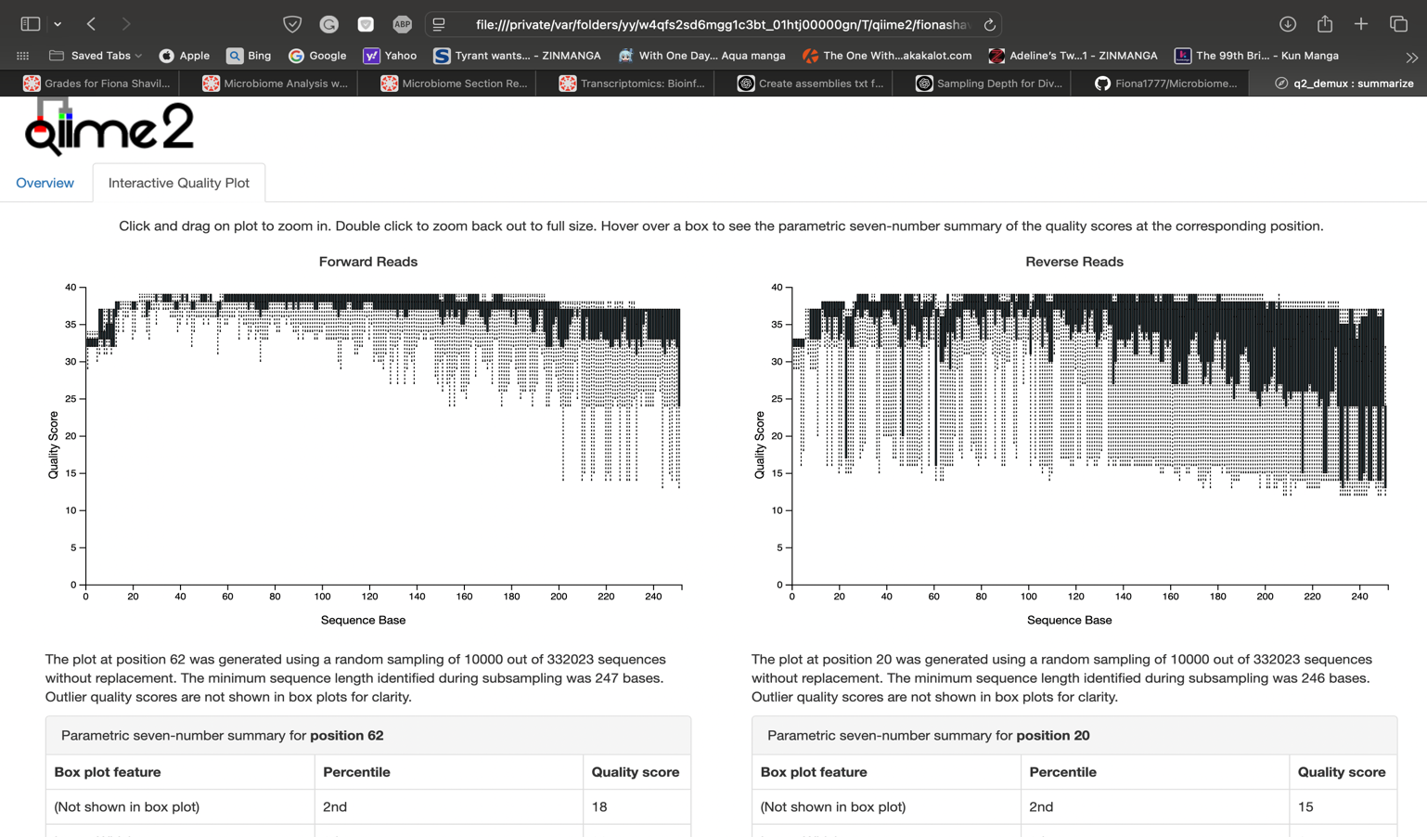

1. Yes, there are 16 in total with less than 10,000 reads. There are 147_S172_L001, 80_S123_L001, 206_S124_L001, 386_S173_L001, 11_S125_L001, 375_S99_L001, 56_S151_L001, 273_S101_L001, 79_S103_L001, 267_S150_L001, 339_S174_L001, 179_S127_L001, 124_S152_L001, 270_S126_L001, 164_S100_L001, & 302_S171_L001.

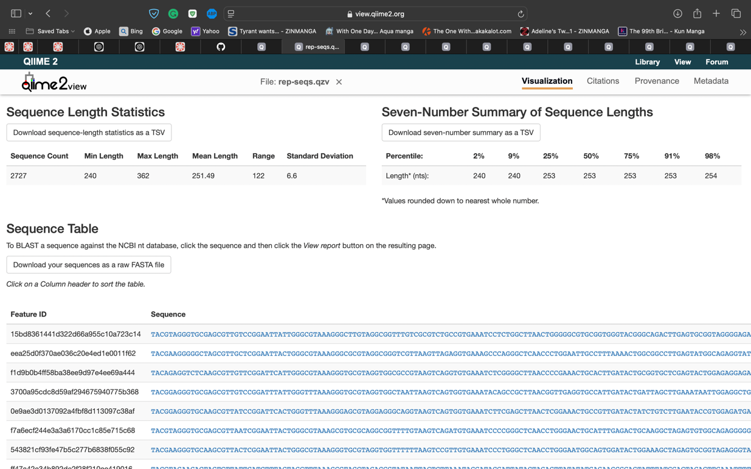

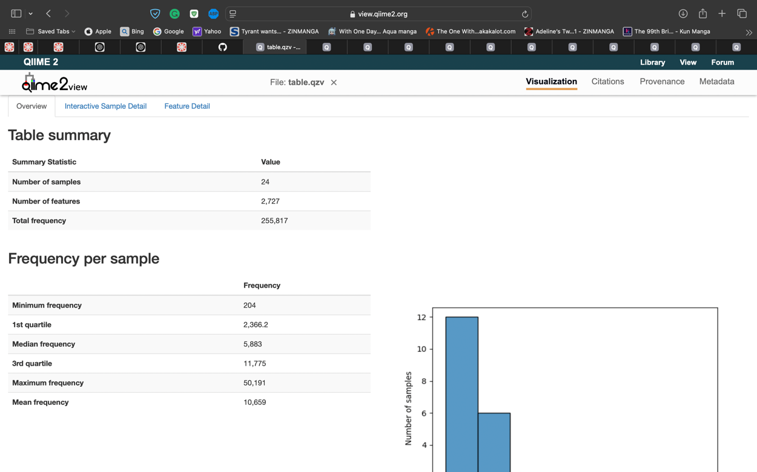

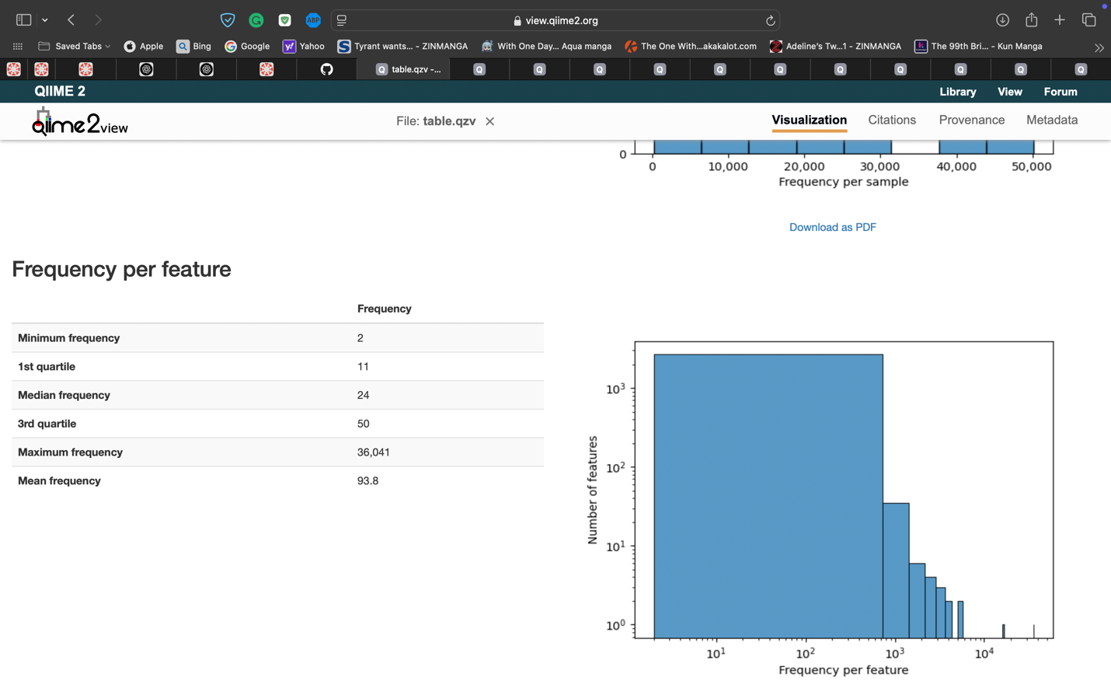

1. My top 3 hits sorted by confidence levels are 0.9999999339764707, 0.9999998136930262, and 0.9999997261496054. When sorted by taxon by top 3 hits were all unassigned.
2. Level 3 of taxonomy would be Class. A trend I noticed was that most of the top hits based on confidence were from the class alphaproteobacterial, cytophagia, actinobacteria, and grammaproteobacteria.
3. The cutoff value I would choose is 9,000 as it contains adequate amount of samples with high reads, while discarding the samples under 9,000 as it wouldn’t be ideal for alpha and beta diversity.

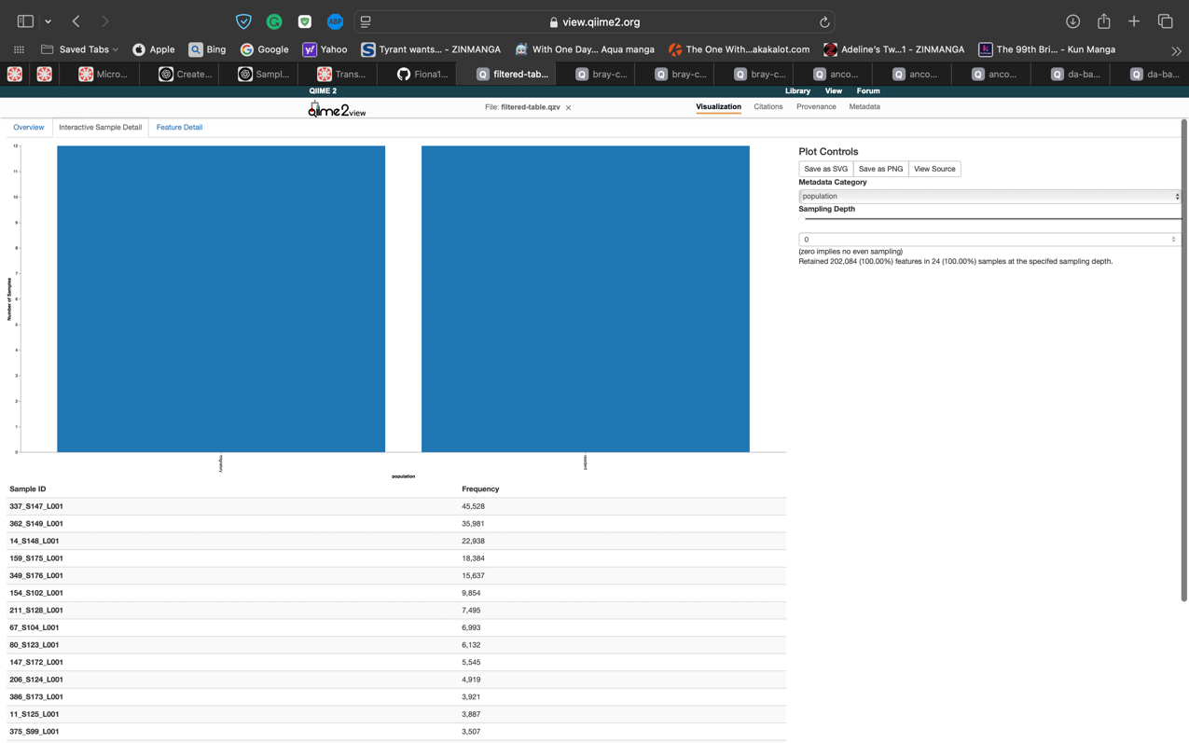

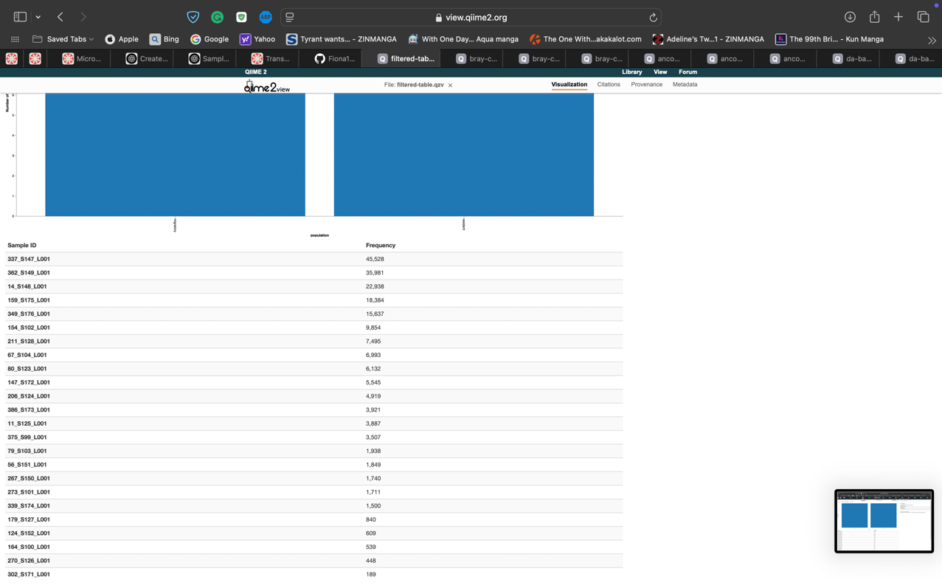

1. Alpha diversity measures the richness and evenness of the samples provided. The differences between the two alpha diversities used is that for observed features it measures the numbers of unique taxa in the samples, which only focuses on the richness of the sample. While Shannon diversity measures the combination of richness and evenness, which focuses on the number of taxa present how are they are distributed.

|  |  |  |
| --- | --- | --- |
| Category | Alpha Diversity Metric | q-value |
| Population | Shannon | 0.698535 |
| Population | Observed Features | 0.196706 |
| Sex | Shannon | 0.366157 |
| Sex | Observed Features | 0.438578 |
| Flock | Shannon | 0.514897 |
| Flock | Observed Features | 0.428858 |

No, there aren’t any significant comparisons between the metadata as all q-values are < 0.05.

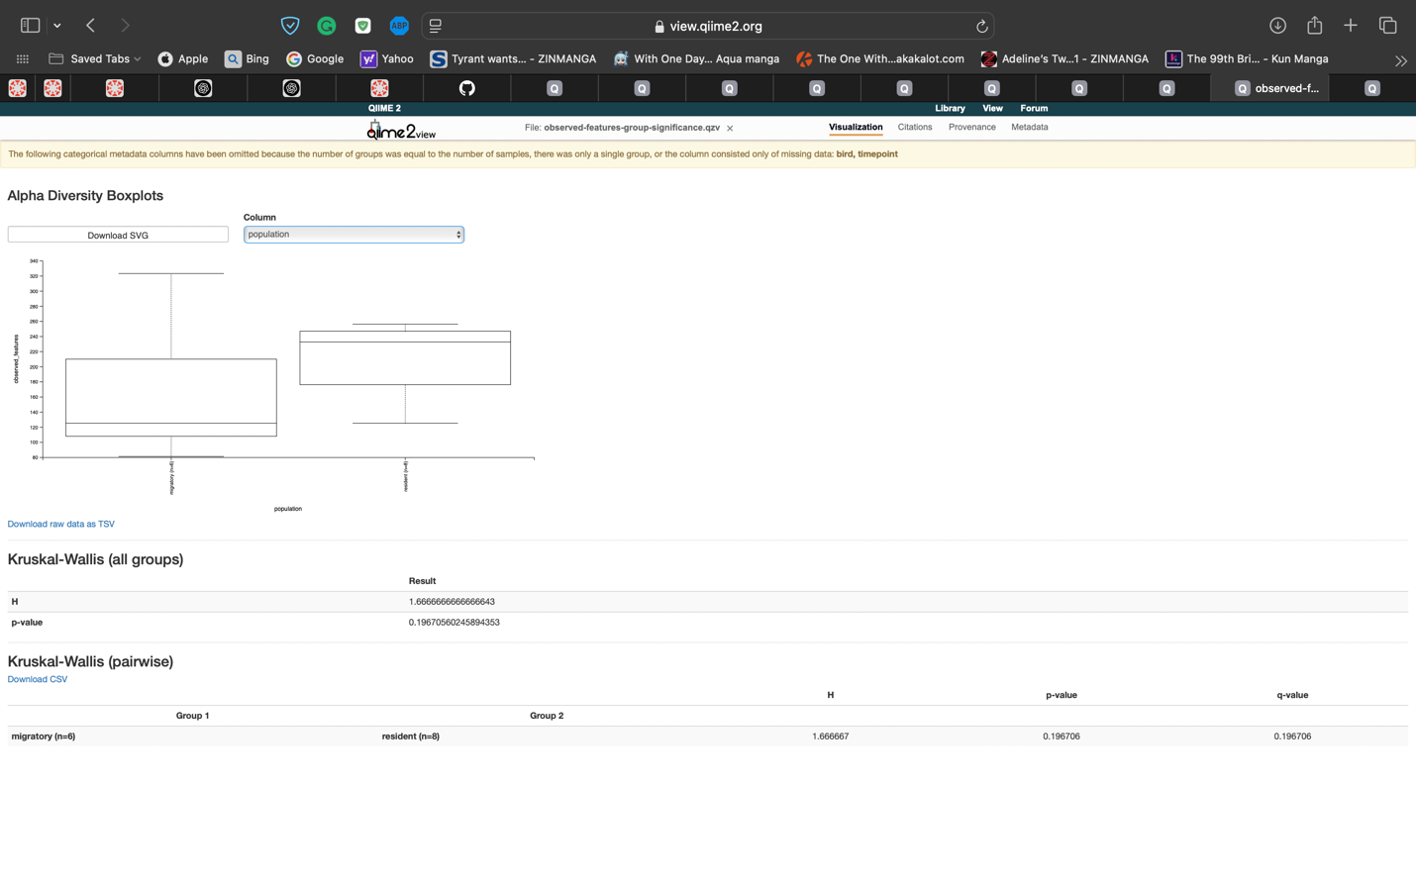

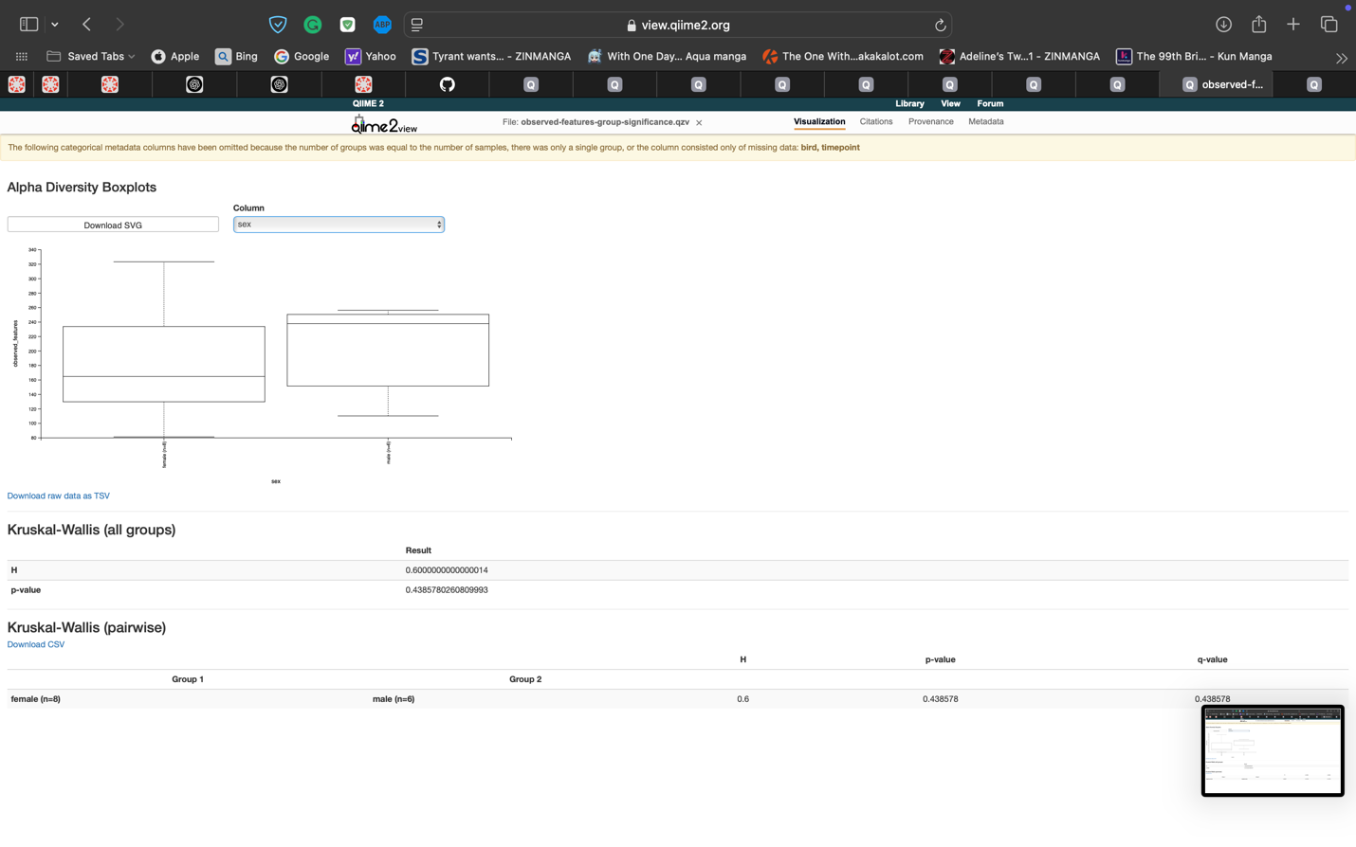

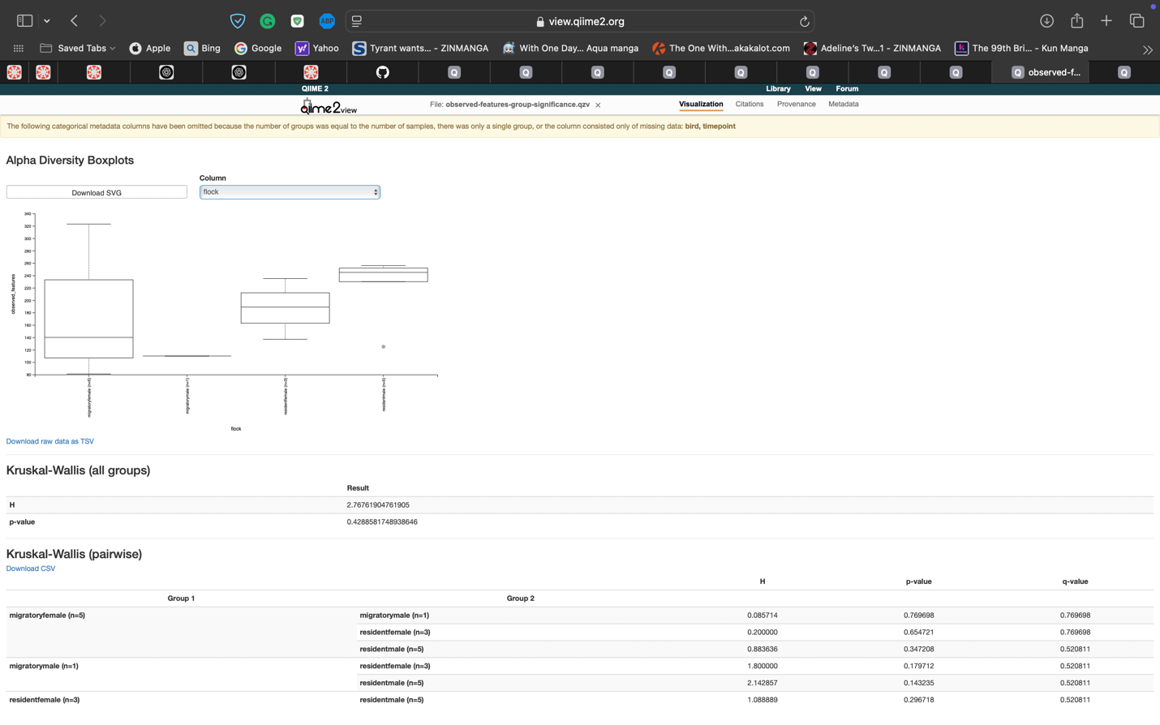

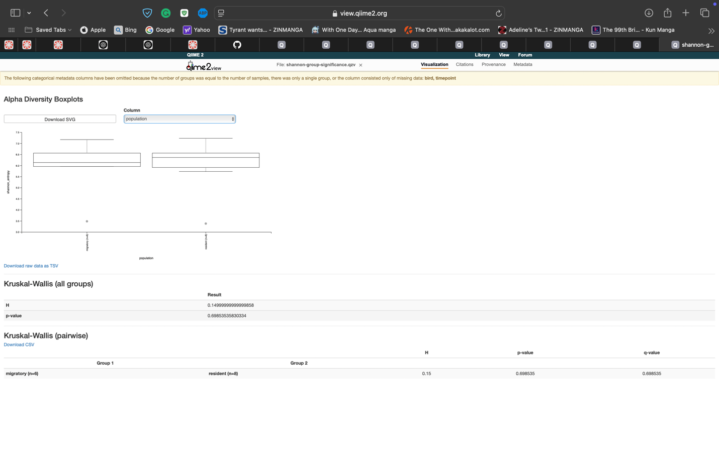

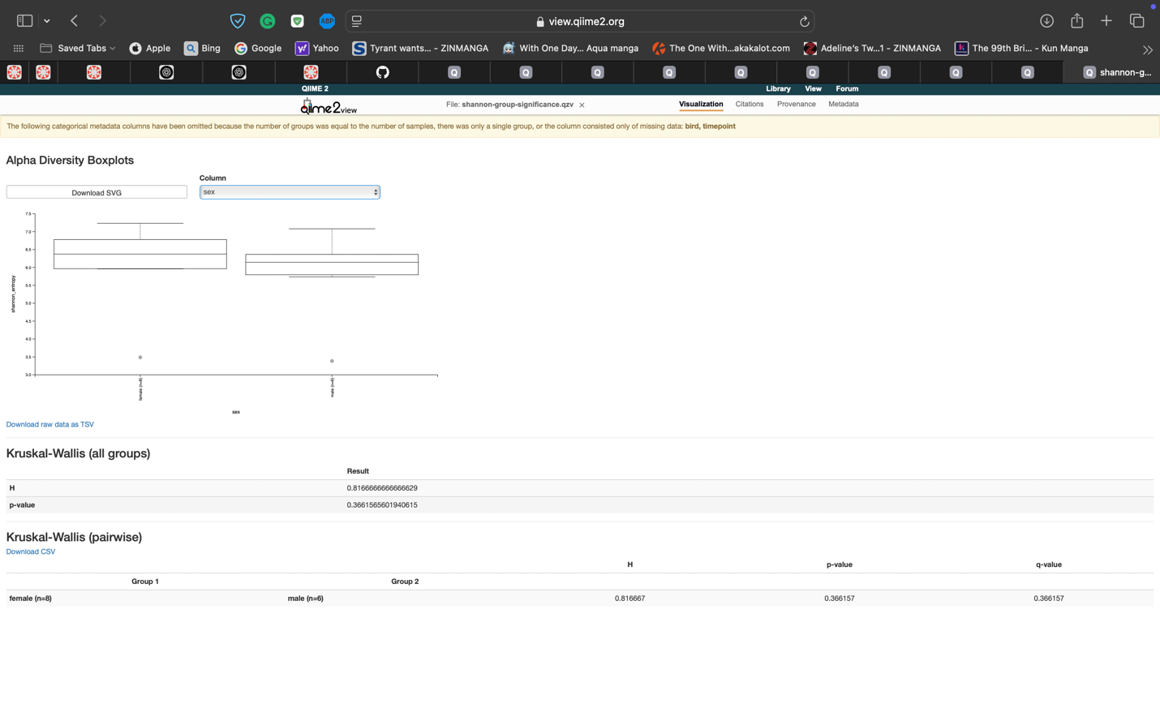

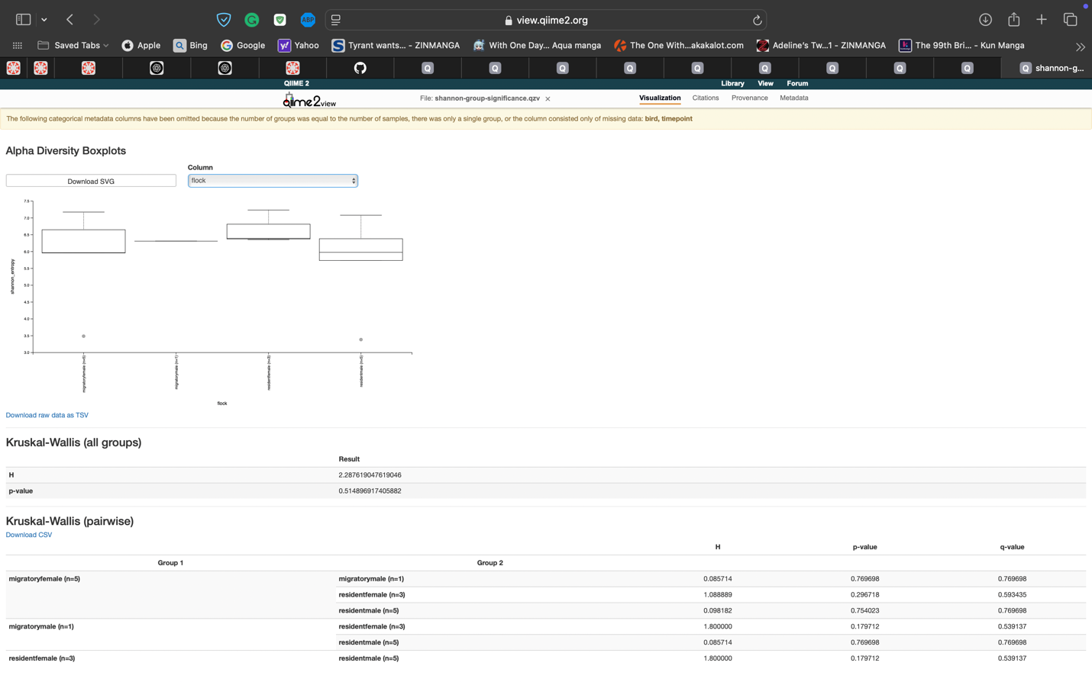

1. Yes, there are significance in population (p-value 0.049) and flock (p-value 0.022). This shows that population, resident vs. migratory birds is different. While flock shows a difference between the different groups.

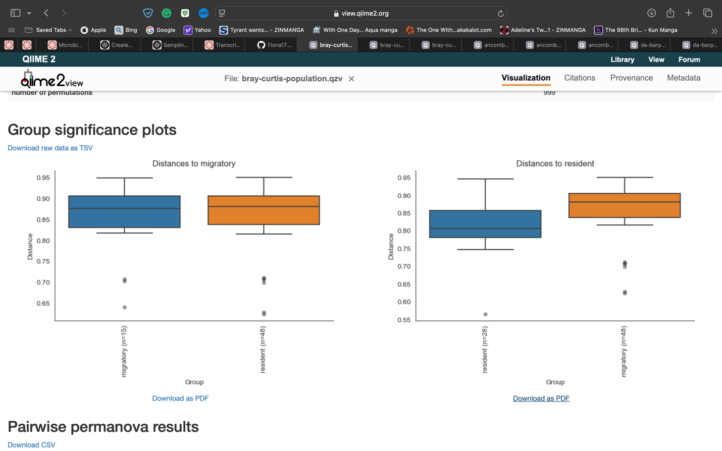

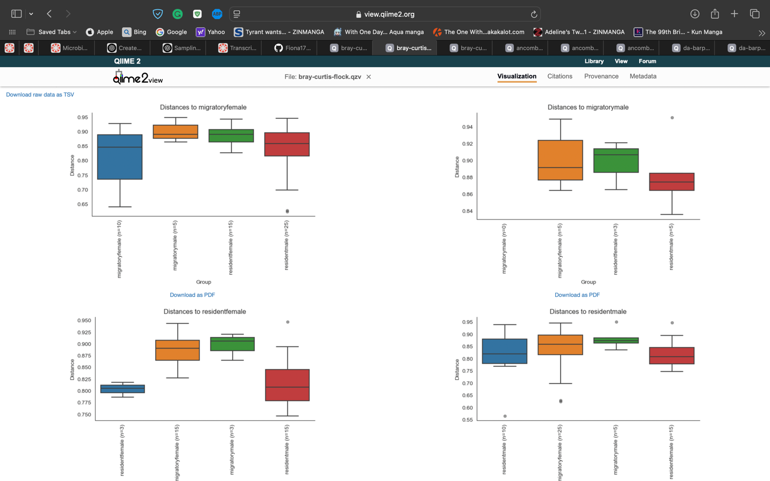

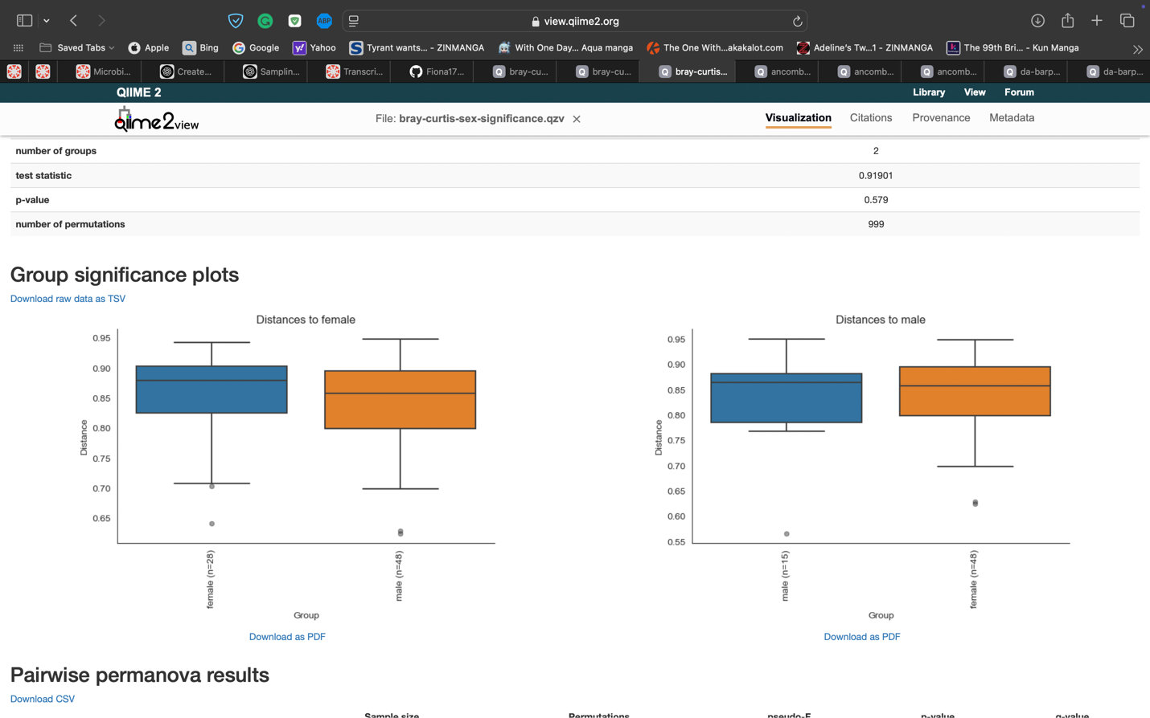

1. It helps visually confirm the patterns as all data is in one plot. Since population and flock showed significance there should be clusters of the similar groups together. For population you can see the migratory being lower on the axis compared to the residents.

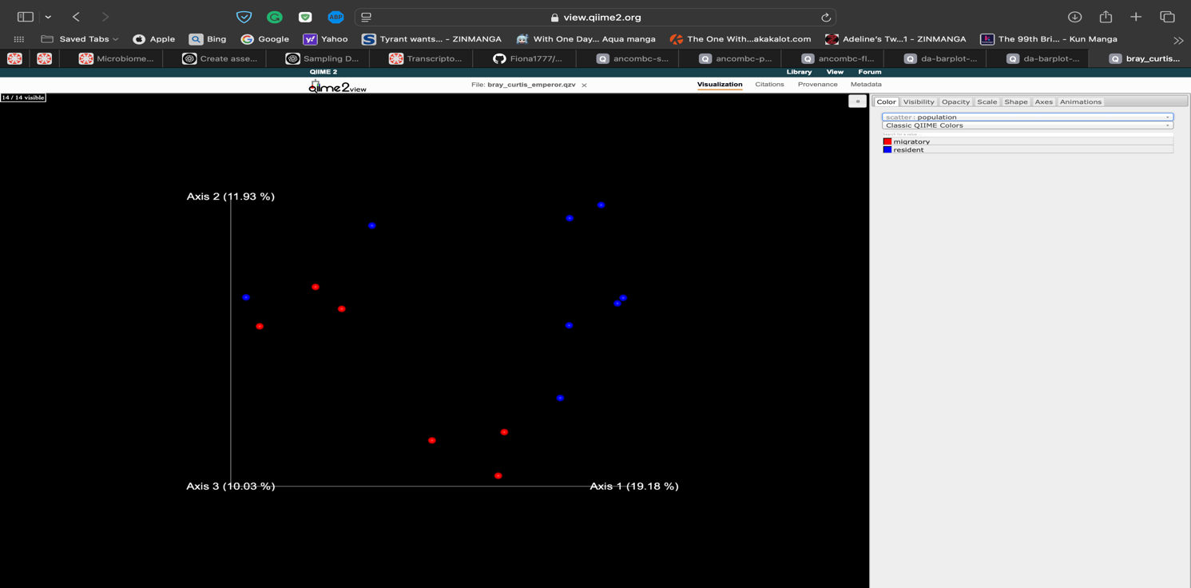

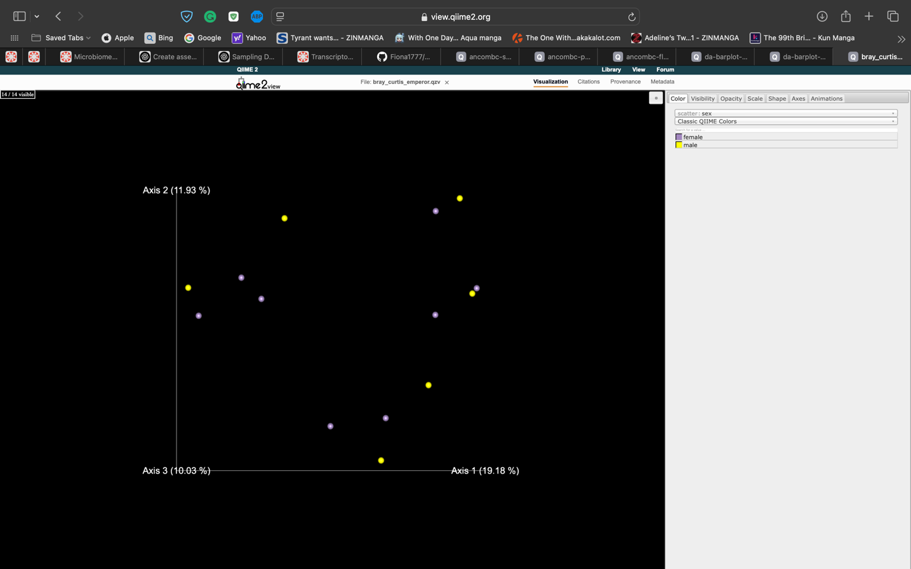

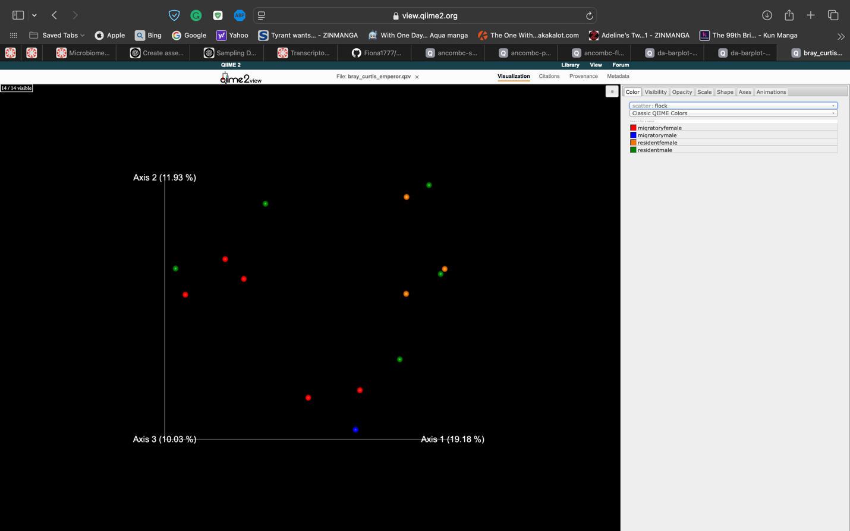

1. Lactobacillaceae,

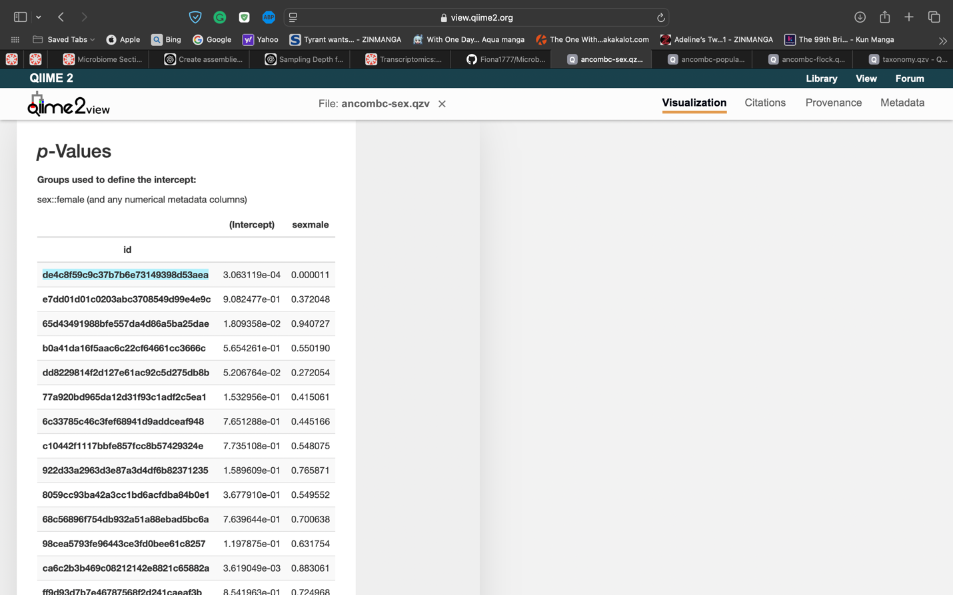

Comamonadaceae

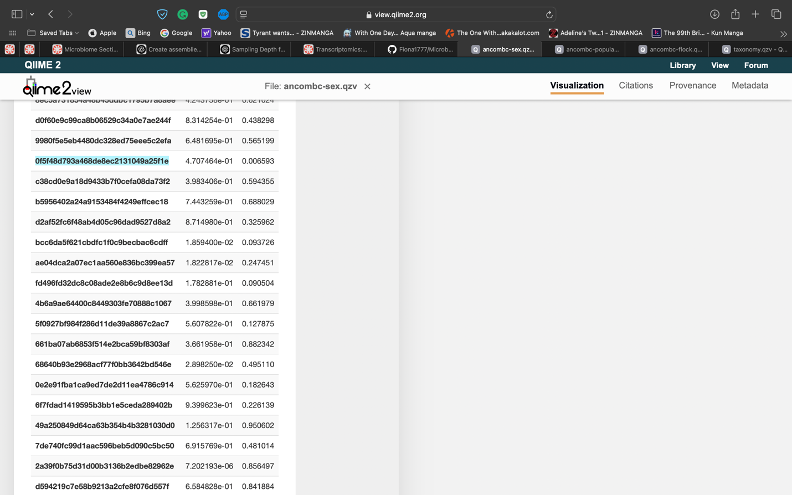

Rhizobiales

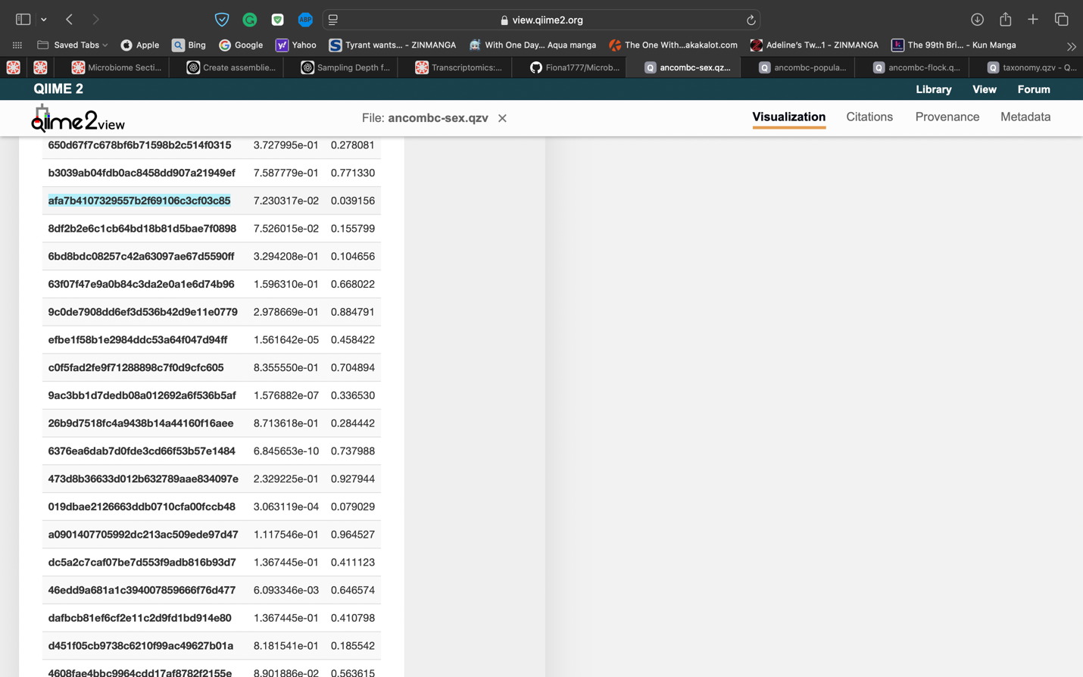

Solirubrobacterales

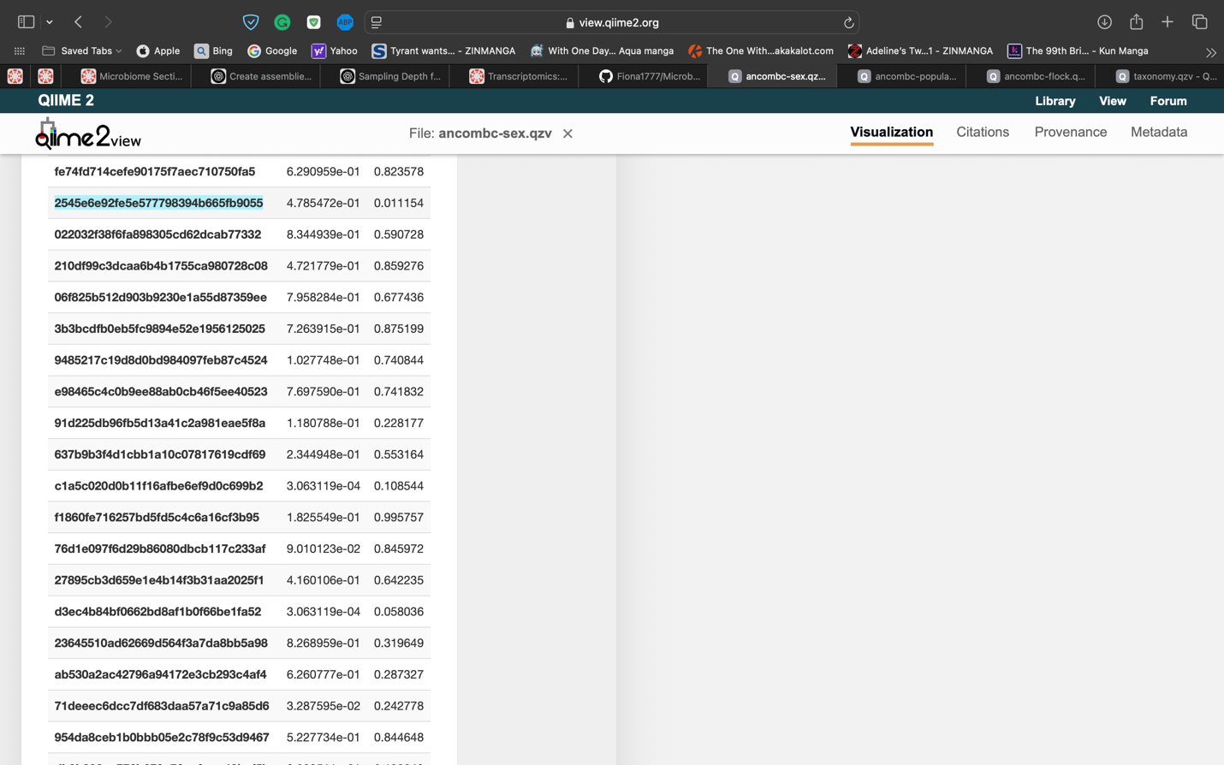

cryoconitis

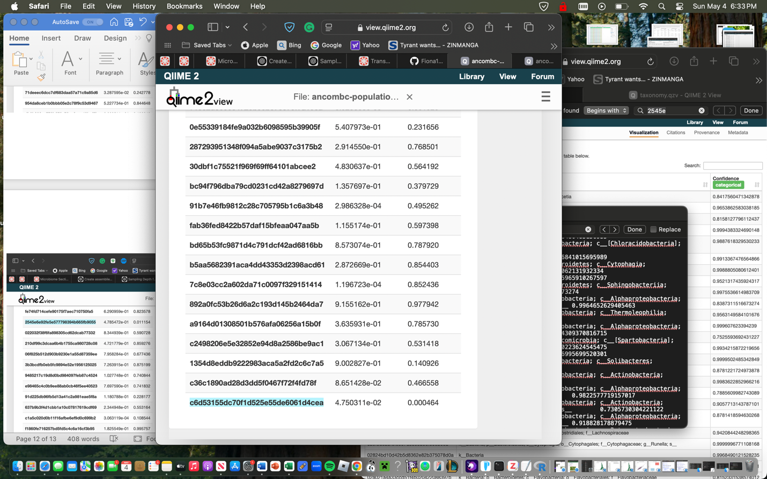

Campylobacter

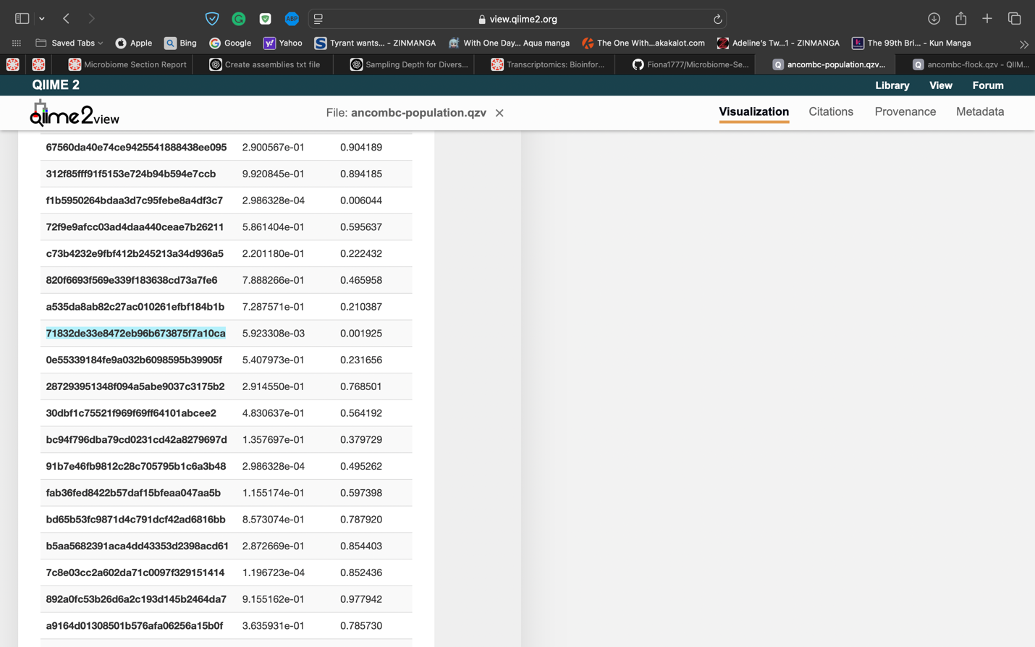

Brachybacterium

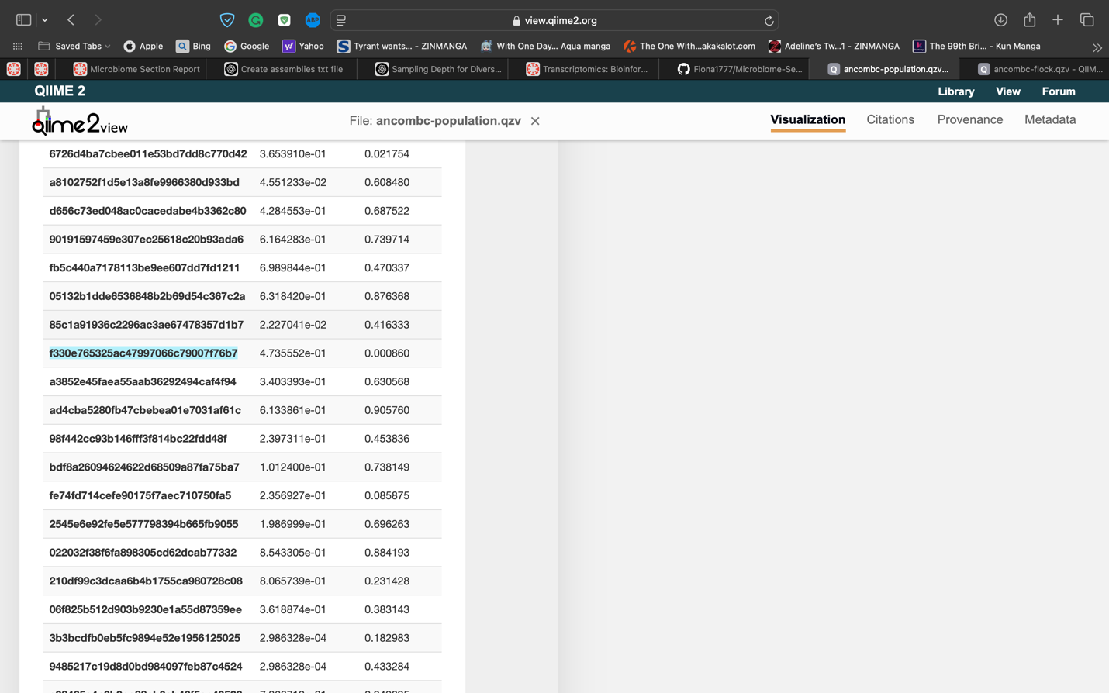

cryoconitis

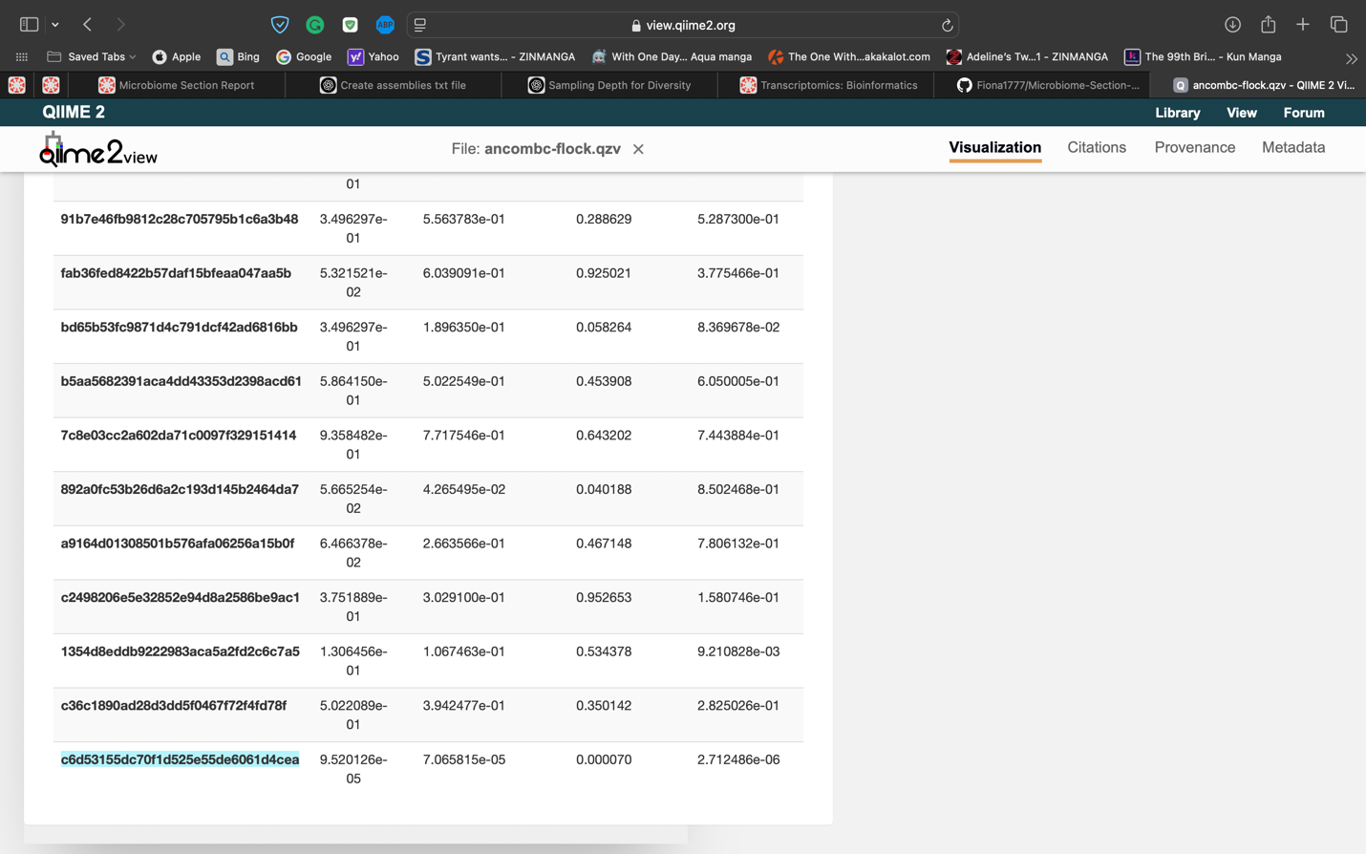

Lactobacillaceae

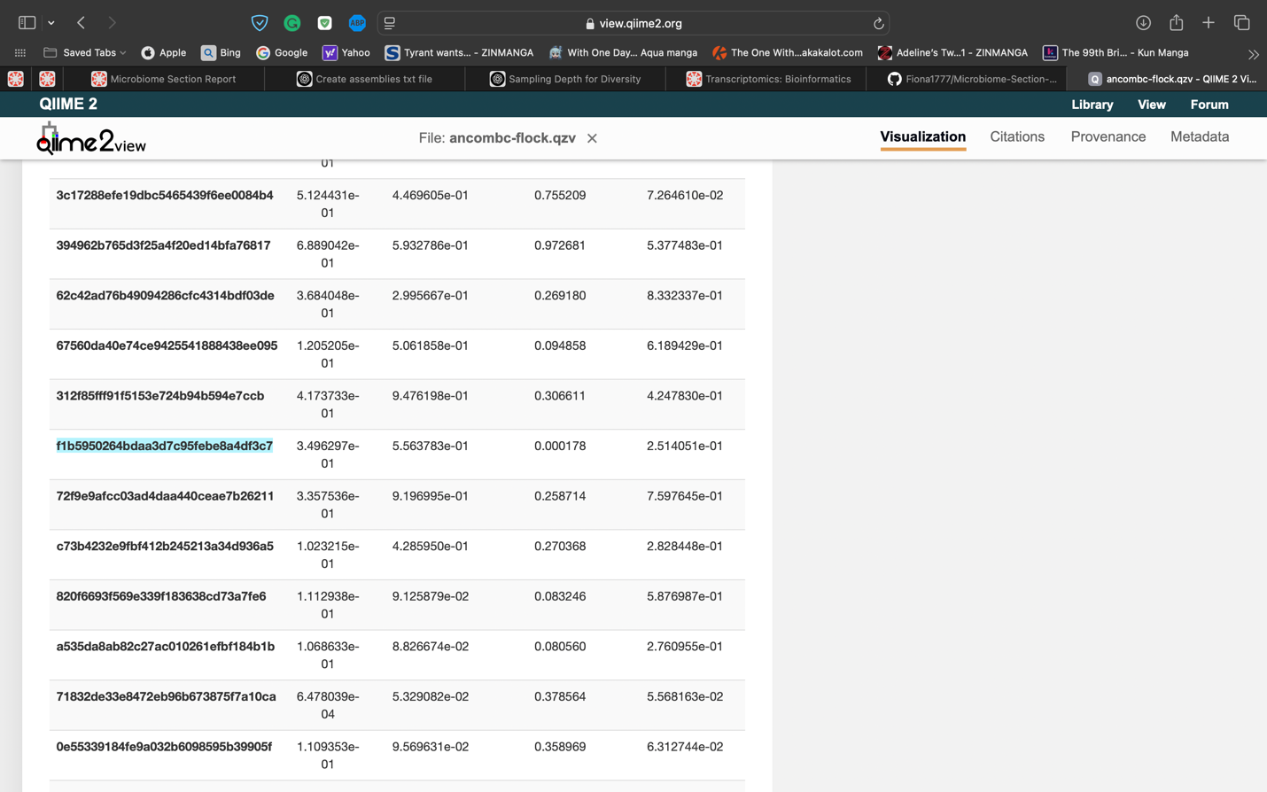

E.coli

